**Brooklyn torah gazette**

**For parshas shemos 5783**

Volume 7, Issue 18 (Whole Number 325) 21 Teves 5783/ January 14, 2023

**Printed L’illuy nishmas Nechama bas R’ Noach, a”h**

For a free subscription, please forward your request to [***keren18@juno.com***](mailto:keren18@juno.com)

Past stories can be found on the website **ShabbosStories.com**

**How Strangers Gave a Holocaust Survivor**

**A Jewish Funeral**

**By Baila Brackman**

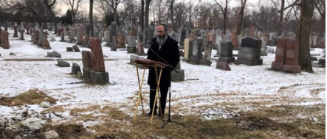

**Rabbi Yossi Brackman conducted the funeral for Jakob Messer, a child survivor of the Holocaust.**

CHICAGO—Time is vitally important, especially when it comes to helping someone in a critical situation.

Living on the rough-and-tumble South Side of Chicago, it had been decades since Jakob had been in contact with organized Jewish community life, which is mostly concentrated in the city’s northern sections.

A child Holocaust survivor, he had wandered far from the religion of his youth, having built a life for himself as a devoted husband, father and grandfather to a large non-Jewish family.

By now in his 80s, his health had taken a turn for the worse, and it appeared that his life was coming to an end.

A relative in Toronto heard the news and was concerned that Jakob’s non-Jewish family would not know to give him a Jewish funeral. The fact that money was tight made the chance of a burial—Jewish or non-Jewish—all the more unlikely.

He shared his worry with his local Chabad rabbi, Rabbi Levi Blau from the Jewish Russian Community Centre of Ontario, who reached out to my husband, Rabbi Yossi Brackman.

Jakob was receiving hospice care at home, and without immediate intervention, it would be difficult to stave off a cremation.

**Comforting the Family**

My husband promptly drove to the home to meet, comfort and speak to the family, hoping to share with them the importance and significance of a Jewish burial.

Rabbi Brackman was welcomed into their home and introduced to Jakob, who was lying in bed, surrounded by his family. His deteriorating body was covered in tattoos. Despite his weak state, he smiled warmly, still full of life, and was comfortable sharing whatever was on his mind.

In fluent Yiddish, Jakob spoke of his memories of a distant past, sharing how he was born in 1936 in Poland and was just a toddler when his mother passed away and the family fled to Russia in 1939 to escape the Nazis. With the help of his uncle, they emigrated safely to America and rebuilt their lives. Although he had strayed from Jewish observance, Jakob was a family man, devoted to his loved ones and community, and always eager to help in any way.

His wife described their dire financial situation, and it was clear that the $1,000 that remained in their bank account would not cover the burial expenses. To them, cremation was the only option.

Rabbi Brackman calmed their concerns and guaranteed the family that he would find a donor to cover the entire cost.

After the meeting, he shared his findings with Rabbi Blau.

**Providing for the Expenses**

The following Shabbat, a young member of Rabbi Blau’s congregation celebrated his bar mitzvah. After the ceremony, Rabbi Blau invited the remaining guests to join him around the table for an intimate *farbrengen*. He shared Torah teachings and stories, sang songs and offered inspiration to those who had gathered.

Without giving it much thought, he reflected on what had transpired over the past week: By Divine providence, a fellow in Chicago reached out to his brother, a member of his congregation in Toronto, for advice on how to help their cousin Jakob in Chicago have a proper burial. In turn, Rabbi Blau contacted my husband and asked him to visit Jakob.

**Friend of an Executive of a Chicago Jewish Funeral Home**

Among the guests was a man named Ari Rosenzweig. He listened intently to the discussions. Early the next morning, he had planned a trip to Chicago for a Chicago Bears game. One of his friends, an executive at a Chicago Jewish funeral home, was going to meet him at the stadium.

Without much thought, he offered to enlist the help of his friend or even pay the entire sum of the burial expenses if needed. The chain of kindness was growing from Chicago to Canada and back.

Three weeks later, as we were preparing for Chanukah, Jakob passed away. We knew without a shadow of a doubt that Jakob was going to be buried with the utmost dignity and respect.

My husband called Ari to let him know that the time had come. He responded with overwhelming emotions. That day was the *yahrzeit* of his own grandmother, a Holocaust survivor, whose own parents had been cremated in the camps. He could not have imagined a better way to honor the memories of his grandmother and great-grandparents than to gift a Holocaust survivor with a proper Jewish burial.

**Making a Minyan in a Snow-Dusted Jewish Cemetery**

Community members and students from the University of Chicago, where we run our Chabad House, came together to make a *minyan*.

And on a frosty morning in a snow-dusted Jewish cemetery, Jakob Messer was laid to rest among his people. He was escorted on his final journey by his family and volunteers who gathered to respect and honor another Jewish soul.

My husband recited Kaddish and arranged for the prayer to be said for the entire year of mourning.

May the soul of Jakob Messer (Yaakov ben Volf), a Holocaust survivor, and all our departed loved ones have a powerful elevation on high.

*Reprinted from this week’s website of Chabad.Org website.*

**Rav Avigdor Miller on**

**Naming Our Children with**

**The Names of Wild Animals**

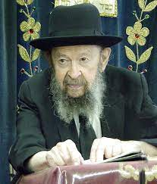

**QUESTION:** **Why do Jewish males have names of beheimos temeios, of non-kosher wild animals? I’m thinking in particular about the name Dov, the bear, and Aryeh, the lion.**

**ANSWERS:** Why do Jews have names of animals, like the bear and the lion?  The answer is that these names are really prayers.  Every name is a tefilah.  It’s a prayer that this Jew should have a quality of gevurah. He should be a hero.

Now, when you see a bear walking down the street at night, you’re not going to walk up and shake hands with him.  If you see him even five blocks away, you’ll stop a taxi and you’ll take it in the other direction. If there’s no taxi, you’ll climb the telegraph pole.

A Jew has to be a bear.  A bear means he has to be a hero.  He has to be strong and he has to be willing to go into combat for the honor of Hashem.  A Jew has to be a lion. He has to be strong-willed and fearless like a lion. A Jew has to be all the good things.

Binyamin ze’ev yitrof (Vayechi 49:27). Not only we give names but Hakodosh Boruch Hu, by means of His prophets, gave names like that. Binyamin ze’ev yitrof. He’s a wolf.  A wolf is hungry, always hungry, and Binyamin is hungry for mitzvos.  He’s hungry to serve Hashem.  He doesn’t serve Hashem like somebody who has to do it; he can’t help himself so he forces himself. No; for avodas Hashem he has an appetite like a wolf.  When a wolf eats up a sheep, he doesn’t do it leshem mitzvah, like somebody who ate a lot on erev Shabbos and now on Friday night he’s not able to eat any more but what can he do; he has to sit down at the seudah and eat some more.  No!  He’s hungry for mitzvos.  That’s why you call him a wolf.  And therefore, all these names represent certain desirable characteristics of service of Hashem.

*Reprinted from the January 8, 2023 email of Toras Avigdor (Tape #441 – January 1983).*

**The G-dliness of the Human Hand**

**From the Teachings of the Lubavitcher Rebbe**

**Rabbi Menachem Mendel Schneerson, Zt”l**

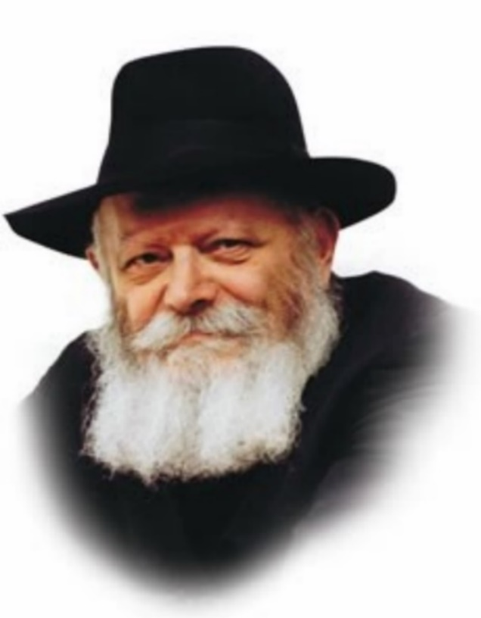

In this week's Torah portion, Shemot, we read the incident where Moses came upon two Jews (Datan and Aviram) in the midst of an argument. When one man lifted his hand to strike the other, Moses cried out, "Rasha! (Evil one!) Why do you strike your fellow?" Moses called him a rasha even though he had not yet delivered the blow, as the very act of raising one's hand against another person is forbidden.

Any individual who lifts his hand against another is termed a rasha, even if he does not actually hit him. But why is it prohibited to raise one's hand?" Why is it considered such a serious transgression?

To explain:

Man was created for the sole purpose of serving his Maker, to learn Torah and perform mitzvot in accordance with G-d's will.

The human body is comprised of many different limbs, each one of which must be properly utilized in the service of G-d. Some mitzvot are performed with the feet, others through the power of speech, and yet others with the nose. Each and every limb has a specific purpose, designed to carry out its own particular commandments.

So too has the human hand been created to perform G-d's mitzvot. There are many commandments that are done with the hands: donning tefilin, building a suka, lighting Shabbat candles, etc.

The hand is especially suited to perform the mitzva of tzedaka (charity). With our hands we take a coin and give it to a poor person or place it in a tzedaka box, as the Torah enjoins us: "You shall surely open up your hand."

The primary function of the hand is to do good for others. When a person argues with his fellow man and lifts his hand as if to strike him, he is using that hand to bring him harm -- the opposite of the purpose for which it was created.

**G-d Created the Human Hand for Good**

For this reason, Moses called the man a rasha, for it is evil to use the hand which G-d has created for good in a negative fashion. Indeed, it is a serious transgression to pervert the potential for good into a potential for evil. Moses therefore became angry even before the blow was delivered.

A person who hits his fellow and causes him pain commits a sin "between man and his fellow man."

A person who lifts his hand in anger, even though he does not strike the other person, commits a sin "between man and G-d" by distorting the very purpose for which the hand was created.

Let us therefore use our hands -- and all our limbs -- to carry out G-d's will and serve Him. For that is the true purpose for which man was created.

*Adapted from Likutei Sichot, Volume 31.*

*Reprinted from the Parshat Vayechi 5783 edition of L’Chaim (Issue #1755) Adapted from Likutei Sichot, Volume 31.*

**Rabbi Berel Wein on**

**Parshas Shemot 5783**

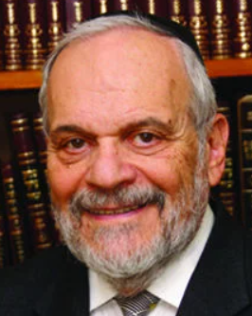

The Torah leaves us basically unprepared for its description of the events that are recorded for us in this week’s parsha. When we last left the family of Israel at the conclusion of last week’s parsha of Vayechi, the Jews found themselves comfortable, affluent, protected and settled well in the land of Goshen.

The Torah does not describe to us the process by which this situation so radically changed into becoming a slave state for the Jews. It only tells us of a new king who didn’t know Yosef and, for reasons not explicitly mentioned in the Torah, became a hater and persecutor of the Jews.

The Torah seems to indicate that this is almost a natural state of affairs – to be expected. The Egyptian exile begins on a high note, deteriorates into abject sorrow and attempted genocide and ends with miraculous redemption. The Torah does not dwell upon any motives for the occurrence of this pattern of events. What did the Jews do wrong? Why was the Pharaoh such a hater? What were the economic or social factors of the time that allowed for such a dramatic worsening of the Jewish position in Egypt?

The Torah addresses none of these issues. It is almost as if the Torah wishes us to understand that these things happen blindly in human history. And, particularly in Jewish history, that the attempts of historians and sociologists to explain these irrational events and behavior patterns are really useless.

As has been often pointed out, all subsequent Jewish exiles – Babylonia, Spain, France, Germany, Eastern Europe, the Moslem Middle East – all seem to eerily conform to this original Egyptian template. As usual the Torah leaves us with more questions than it provides answers for. In effect, that is why the Torah is called the book of human life.

We are also unprepared to recognize the savior of Israel in the person of Moses. We are told how he was miraculously saved from the crocodiles of the Nile by the daughter of the Pharaoh and raised in the royal court. He sympathizes with the brutalized Jewish slaves, defends them, and is forced to flee from Egypt.

We hear nothing regarding Moses for the next sixty years until he reemerges as a shepherd in Midian, married to the daughter of Yitro, the local religious chief who, at this time, is still a pagan. Hardly the resume’ that one would expect for the leader of Israel, the greatest of all prophets and the teacher of all human kind.

Where did his holiness and greatness stem from, how was it developed, who were his mentors and what were his experiences over those long decades of separation from his people? The Torah gives us no clue or answer to these questions. It effectively points out that greatness oftentimes comes from unexpected sources and from people and leaders who operate outside of the usual establishment circles.

All of life is a mystery and certainly the Jewish story remains in its base an inexplicable one. This sets the stage for everything else that will now follow in the Torah. It is why the Jewish people, when accepting the Torah pledge to G-d that “we will do and then perhaps try to understand,” if we wish to understand first we will never come to do. The Divine hand guides us but it is never subject to our rational thoughts and explanations.

Shabbat Shalom!

*Reprinted from this week’s website of rabbiwein.com*

**The Challenge of**

**Being G-d-Fearing**

**By Rabbi Yisroel Bronstein**

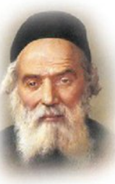

*– But the midwives feared G-d and they did not do as the king of Egypt spoke to them... (1:17).*

A student of the Chofetz Chaim was asked by a Lithuanian community to become their Rav. He was hesitant to accept the position lest he inadvertently rule incorrectly regarding halachic matters.

The Chofetz Chaim advised him to accept the position, using the above pasuk (verse) as proof, explaining as follows: When Pharaoh ordered that the midwives murder every Jewish male child upon birth, the Torah states that they feared Hashem and they therefore defied Pharaoh’s command.

Why did the midwives not resign from their posts as soon as they received the cruel command? It was because of their deep fear of Hashem that they chose not to leave their positions – for perhaps those who would replace them would be unscrupulous women who would carry out Pharaoh’s wicked decree.

“The same idea can be applied to the rabbanus,” the Chofetz Chaim told his student. “It is precisely because you are G-d-fearing and you worry about possibly ruling incorrectly that you should accept the offer to become their Rav! For if you turn down the position, who knows who will be hired instead of you?” (A Shabbos Vort, ArtScroll)

*Reprinted from the Parshas Shemos 5783 email of The Weekly Vort.*

**Sanctifying His Name**

**By Rabbi Shraga Freedman**

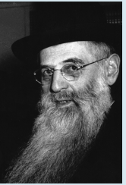

**Rav Chaim Mordechai Katz**

If a person lives with the sense that he has a mission to accomplish even in the context of his (seemingly) mundane business dealings, he can be capable of performing earth-shattering acts of kiddush Hashem. That is exactly what took place at the closing of one extraordinarily lucrative business deal on the West Coast of the United States after years of intense negotiations.

The parties were about to conclude the deal, and the buyers and sellers had gathered in a conference room to work out the final details. One of the major investors was a Mr. Gershon Kamin (name changed) of New York, a man whose participation was critical to the deal and who stood to earn a fortune from its successful conclusion.

During the course of the final discussions, Gershon became very disturbed by one of the attorneys working for the other side. The man was simply unable to refrain from using vulgar language. Every other word he uttered was an expletive of some sort. Gershon politely asked the lawyer to refrain from using profanities, and the man promised to do his best. But the use of such language was apparently deeply ingrained in his personality, and the lawyer continued to slip.

Finally, Gershon grew incensed and warned the lawyer, “If you utter even one more profanity, the deal is off!”

It did not take long before the lawyer inadvertently let slip an offensive word again, and Gershon simply stalked out of the room, scuttling the entire, unimaginably lucrative, deal.

**Shocked by Gershon’s Abrupt Departure**

Larry Fisher (name changed), another religious Jew who was present at the proceedings, was shocked by Gershon’s abrupt departure. Larry was aware of the years of hard work that had gone into the deal. Where had Gershon derived the inner strength to make such a sacrifice? Larry lived with this question for several years, until he happened to hear a lecture from a noted rav that delivered the answer.

The rav told a story about a man named Gershon who had been learning at the Telshe Yeshivah in Cleveland, Ohio, decades earlier. As a bachur, he had demonstrated great promise, and he seemed to have a stellar future in the beis medrash. But Gershon’s parents wanted him to pursue a career, and with great reluctance, he agreed to leave the yeshivah to obtain a degree.

On his last day in the yeshivah, Gershon was learning diligently in the beis medrash when he was summoned to the office of the rosh yeshivah, Rav Chaim Mordechai Katz, for a last farewell conversation. Gershon was certain that the rosh yeshivah would admonish him to maintain his learning sedarim or to continue to daven with a minyan when he entered the business world.

**One Concern Above All Else: Sanctify Hashem’s Name**

But Rav Katz had something else in mind. “Gershon,” he said, “you are about to leave the shelter of the yeshivah’s walls and venture into the outside world, where every step you take will be a test. You must always have one ambition, one concern above all else: to sanctify Hashem’s Name. Remember that everything you do will be either a kiddush Hashem or a chillul Hashem, and choose accordingly!”

Gershon took the rosh yeshivah’s words to heart, and that principle became the guiding light of his career. After the lecture, Larry approached the rav and asked, “By any chance, was the boy in your story Gershon Kamin?”

Shocked, the rav exclaimed, “How did you know that?”

“Because I saw with my own eyes just how deep an impact the rosh yeshivah’s message left on him,” Larry replied with feeling (as told by Rabbi Avrohom Chaim Feuer). Years after that fateful encounter, Gershon was able to sacrifice the deal of a lifetime because the rosh yeshivah’s words had infused him with a sense of mission even within the context of his career. In any profession or field, every Jew can do the same.

*Reprinted from the Parshas Shemos 5782 edition of At the ArtScroll Shabbos Table. Excerpted from the ArtScroll book - Living Kiddush Hashem.*

**Archaic Judaism: An Open Letter to Howard Stern**

**By Avi Ciment**

***For so many Jews Judaism is meaningless and non-sensical. It doesn’t have to remain that way.***

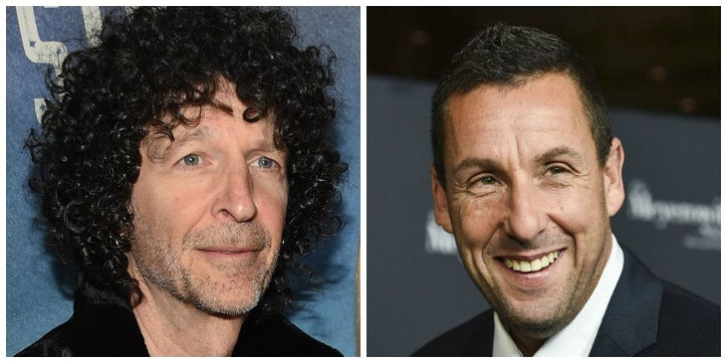

**Howard Stern and Avi Ciment**

Dear Howard,

Someone recently sent me a short clip of you and Adam Sandler reciting your respective Bar Mitzvahs blessings. It was done respectfully – and perfectly I might add – yet at the conclusion, you remarked, “Isn’t it so ridiculous that my parents made me go for hours every week to learn these words and I still have no idea what they mean? It makes no sense to me all these years later.”

I cannot tell you how many Jews feel the exact same way, and have said goodbye to a religion whose languages and traditions are as foreign to them as Shintoism. In fact, for a very short time, I taught afternoon classes in a Reform Temple to very uninterested kids who were forced to memorize prayers and speeches that had little meaning, aside from "tradition" and the prerequisite Bar Mitzvah photo. So, I get that.

Add to that the fact that I myself did not fit in the box, and found myself confused about many practices that at the time made little sense to me. When I was younger, Rosh Hashanah was more about wearing a new suit and staying awake during a speech I couldn't understand, rather than about appreciating the opportunity of asking G-d to grant me a favorable year.

Add to that having to withstand the shrills of an Israeli cantor whose bellowing voice should never have met an eardrum. I'm not even going to mention Yom Kippur. And someone actually paid for this no less!

Do you remember in the film classic,*The Karate Kid* when Danielson comes to train with his Sensei, Mr. Miyagi. For several back breaking days, Myagi has Danielson sand a large wooden deck, paint huge fences and wax a fleet of cars. Finally, he's exhausted and explodes, "Hey I came here to learn how to fight and instead you're having me do all of these random things that make absolutely no sense whatsoever. I am out of here!"

**No Random Exercises**

With that, Myagi proceeds to show him how every single "random exercise" that he thought had no meaning, was actually another tool necessary towards his becoming a champion. The scene's climax occurs when Danielson successfully defends himself against his Sensei's attacks, reinforcing the idea that there was in fact a method to the madness. But when he thought there wasn't, he was fuming – and with good reason.

The commentaries tell us that the Egyptians, like the Nazis, gave purposeless work to the Israelites in order to weaken their spirit by essentially having them waste their days and nights doing meaningless tasks. G-d does not want anyone serving Him unhappily, doing random, purposeless things – especially under the guise of religion.

As I got older, I started learning more and found that I had many misconceptions about Judaism, probably because of a mixture of ADHD, and rabbis who didn't know how to deal with, let alone teach someone like me. Luckily, my parents raised us in an observant home where we discussed the meanings behind many things and I always felt the presence of G-d. And as I got older, rather than dreading the one day a year where I can't eat, I now look forward to and love [Yom Kippur](https://aish.com/yom-kippur/) because I now see it in a different light.

**My understanding of things changed as I learned the reasons behind what I was doing.**

What changed? Like Danielson, my understanding of things changed as I learned the reasons behind what I was doing. I realized that everything has meaning, but it is usually our limited perception, many times through no fault of our own, that prevents us from seeing the larger picture.

As a child, [Shabbat](https://aish.com/shabbat/) was a day to rest, eat a lot, and avoid using any electronics for a day. But it wasn't something I necessarily looked forward to. Today, I see it as my favorite day of the week, a day where I can recharge my own battery, a day to stop producing and start appreciating all of my accomplishments. It's a day to place something bigger than myself in front of me and it gives me perspective, humility, and ultimately gratitude.

**Many Psychologists and Sociologists Appreciate the Value of Shabbos**

Rather than seeing it as a day that I *can't* text, I see it as a day that I *can* put down my cell phone and focus on family, friends and G-d. The fact that many psychologists and sociologists now see the value of the Sabbath even amongst non-Jews further strengthens the message.

So, does that mean it's all smooth sailing? Heck no! I have some issues with religion, and certain people who represent it. But I also know that G-d rescued us from actual slavery some 3,500 years ago, and gave us a Torah vis a vis mass revelation. The event is so cataclysmic in nature that even today, Muslims, Christians and Jews alike still accept it.

When you became a [Bar Mitzvah](https://aish.com/judaism101/lifecycle/bar-bat-mitzvah/) boy, the first blessing you made (the one you recited with Adam Sandler) thanked G-d for choosing you and for His gift, the Torah. The second blessing that you read after your Bar Mitzvah portion was completed also thanks G-d for giving us His Torah, but adds "and implanted eternal life within us." The good deeds you do will stay with you for all eternity. Howard, I have seen you stand up against injustices towards Jews (Kanye and Roger Waters come to mind), constantly defending Israel's right to defend itself, not to mention the love and respect you give your parents, particularly when it wasn't always so easy.

You've also been working on your character in therapy, and clearly trying to become a better, more sensitive person, even extending your kindness to animals. We call this the "*pintele yid*", the unique "holy spark" that resides within every Jew.

My hope is that you and Beth continue to nurture this dynamic of your personality and come to see Judaism as a joy and a privilege and an opportunity to come closer to G-d, as opposed to a meaningless set of archaic traditions.

Continued success!

Avi Ciment

*Reprinted from this week’ website of aish.com. Mr. Ciment teaches Jewish outreach throughout South Florida and is a frequent contributor to the Jewish Press.*